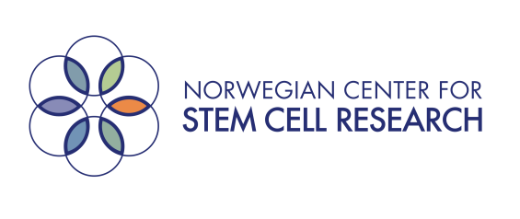

11th Annual Norwegian Stem Cell Networking Meeting
Soria Moria Hotel and Conference Center, Oslo, Norway

October 7-8, 2014

Open to all researchers, clinicians, industry representatives, patient groups and others with an interest in stem cell biology, research and applications

The program will encompass scientific presentations, information about stem cell-related research and clinical consortia in Norway, networking opportunities, and a session on public awareness and media interaction

The scientific program includes glimpses into the future of the stem cell field
through such presentations as:

“Chromatin goes 3D – implications for gene regulation in stem cells”
Philippe Collas (Norwegian Center for Stem Cell Research)

“Cell Origami: 3D self-folding tissue scaffolds”
Iskandar Vasiev (University of Glasgow)

Participants may submit proposals for short presentations of their own research findings. Selection of presentations will be made by the organizing committee. Priority will be given to students and postdoctoral fellows. A prize will be awarded to the best presentation by a PhD student.
Registration: Fill out registration form below and send by email to Ellen Wilmann Staff (at email address: franziska.hartmann@medisin.uio.no)
No registration fee. Travel and lodging expenses covered for participants from outside Oslo.
Deadline for registrations: September 22, 2014
How to get to Soria Moria Hotel and Conference Center
From Oslo City Centre: Take Metro line #1 to Voksenkollen station and
from there walk about 10 min to the hotel*.
*Where is Soria Moria: http://www.soriamoria.no/
Address: Voksenkollv. 60, 0790 Oslo
Registration form (submit by email to franziska.hartmann@medisin.uio.no)

Name: ____________________________________________________________

Affiliation: _________________________________________________________

Address: ___________________________________________________________

Position: ___________________________________________________________

Email: ______________________________________________________________

Telephone: __________________________________________________________

Do you wish to make a presentation? If so, please attach a short abstract (1/2 page)

Presentation title: _____________________________________________________

Housing required? October 7 October 8

Will you attend the conference dinner on October 8?

Note: The following expenses are covered by the conference:

For all participants:
2 conference days at Soria Moria with lunch, coffee, snacks
Conference dinner on evening of October 8

Additionally for participants traveling from outside of Oslo:
Up to 2 nights lodging (dinner not included on October 7)

